Practice: Dealing with Geometric Shapes

**Intro:**

To get more familiar with variables in computer science, we'll be making a program that calculates surface area and volume on various shapes.

Also, so you get better acquainted with the syntax, please refrain from looking at your notes and other references. If you absolutely do not remember how to perform a certain operation, ask a friend first.

**Instructions:**

Before programming:

1. Choose a three-dimensional shape to work with. Examples of this are spheres, cubes, rectangular prisms, etc.

2. Get their respective surface area and volume formulas.

During programming:

1. Request a user to input a length, width, height, radius, or whatever dimensions are required for your specified shape.

2. Figure out the given surface area and volume using the user's input.

3. Output the surface area and volume of the shape.

When you're finished with trying one shape, test other ones out. Be sure to refer to the equation list (above) if in case you've forgotten any.

**BONUS:** Let the user request whether or not they want surface area, volume, or both. This requires the use of if-else statements. If you finish that, let the user request the shape they want, alongside the volume, surface area, or both.  
**Example Output (e.g. a cube):**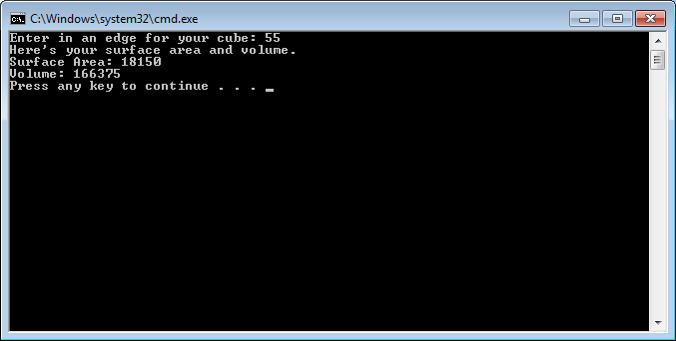

Practice (Challenge): Testing Whether an Integer is Even or Odd

**Intro:**

Thinking back to mathematics: What makes an integer even or odd? Noting that, use the material learned from the exercise, lecture notes, and book to complete this task.

**Instructions:**

During programming:

1. Request the user to input an integer.

2. Test whether or not it is an even or odd integer (HINT: Think of the difference

between an even and odd integer).

3. Output to console.

**BONUS:** Instead of a number, tell the user whether or not it is even or odd. HINT: This requires the use of 'if' and 'else' statements.

**Example Output:** (No need to make this too fancy, that is if you're not doing the bonus section)

